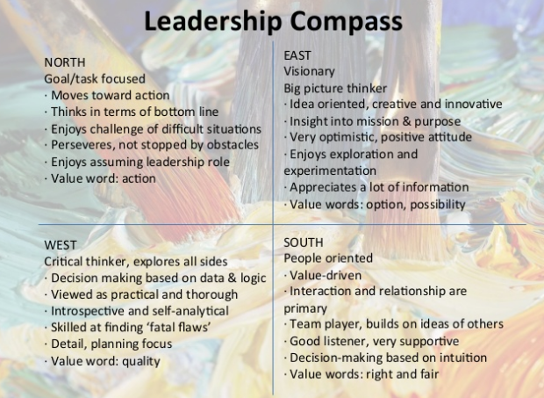
Source- The Personality Compass by Diane Turner and Thelma Greco, 1998

Social Discipline Window
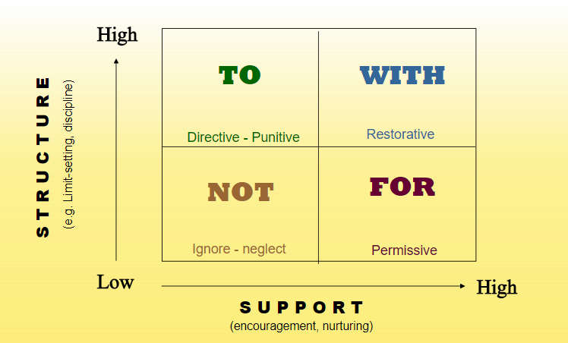
Source - Wachtel & McCold 2003
MOVING SYSTEMS TOWARD RESTORATIVE
Using the Leadership Compass to Steer Change

Questions we will consider together:

What is the “leadership compass”?

Where do I see myself, N, S, E or W?

Where do others see me? (Colleagues, Subordinates, Partners/Spouses, Children/Wards/Mentees)

In my organization those in charge are typically _______. (N, S, E, or W)

Those rewarded or promoted in my profession are typically _______. (N, S, E, or W)

Are we suffering from lack of mindset diversity? Hiring manager me-ism?

How does that promote or inhibit our restorative transformation?

What is the Social Discipline Window?

How does the “leadership compass” line-up with the Social Discipline Window (Wachtel & McCold, 2003)

Where does my ______ orientation mostly live and operate?

What might I need to do to mitigate the challenges of that?

How are you currently ensuring diversity of mindset?

What ideas do you have about how you can better ensure mindset diversity in the future?

