Implementation of a Comprehensive Behavior Support Systems Model
in Jefferson County Public Schools
Dr. Naomi Brahim & Saundra Hensel, Jefferson County Public Schools, and
Dr. Jessica Swain-Bradway, Northwest PBIS Network
Background
Jefferson County Public Schools (JCPS) is a large, urban school district in Louisville, KY, serving over 101,000 students at 175 schools. The student population is very diverse, with 55% students of color, 5.3% receiving ESL services, 66.3% receiving free/reduced lunch, and 6.1% homeless. The district began implementation of a comprehensive Behavior Support Systems Model in 2016 to explicitly address increasing rates of in-school and out-of-school suspensions, as well as ethnic disproportionality in behavior referrals.
The JCPS Behavior Support Systems Model was developed by the district leadership team, with support from national and regional experts. This model is an integration of Positive Behavior Interventions and Supports (PBIS), including evidence-based positive behavior classroom strategies, and Restorative Practices (RP). The goal was to use PBIS as a framework to implement a full range of evidence-based, and promising practices in behavior supports, to the meet the specific behavioral, and relationship needs for students, staff, families, and leadership in Jefferson County.
The range of evidence-based practices included in the Behavior Support Systems Model fall into three categories, reflected in the JCPS Student Support and Behavior Intervention Handbook: Environment, Instruction, and Relationships. The following sections describe the installation, and adaptation of the components of the Behavior Support Systems Model, as the district built capacity and scaled the model from 2013-2018.
Behavior Support Systems Model – Positive Behavioral Interventions and Supports
The district began systematic implementation of PBIS in 2013 with a long term-goal, and strategic plan for district-wide capacity. During the 2013-14 school year, the district trained 50 school teams to implement Tier 1 positive behavior support strategies. Each year following the initial roll out, the JCPS team trained an additional 10-20 additional schools using a cohort training model. By 2018, the JCPS Behavior Team had trained 68% (107 of out of 156) of the schools in PBIS. School sent teams of at least one administrator and representative content area and/or grade level teachers, to attend a series of trainings on a) the use of data analysis for decision-making, b) implementing practices to support student success, and c) installing and strengthening systems to support adult behavior.
The district coordinator created a working plan included dense opportunities for engaging, supporting, and coaching school staff throughout the year. This plan has helped the district with maintaining implementation momentum in the face of predictable obstacles, such as staff turnover, changes in leadership, and shifts in student population demographics. Following the initial trainings, the district established a system of ongoing professional development with a prioritized calendar of monthly training for designated school staff to enhance the PBIS implementation. In addition, the district leadership team allocated 10.0 FTE to the position of Resources Teacher, with the dedicated role of coaching PBIS. These positions were funded through a combination of district general funds and the federally awarded School Climate Transformation Grant.
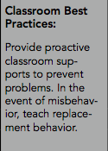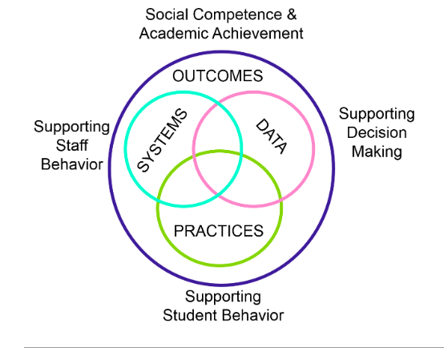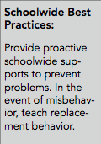
Coaching Supports to Schools
In JCPS, resource teachers are assigned a roster of schools, and provide direct support to the building leads and teams. They attend meetings at least twice per month coaching data-based decision making, including fidelity checks, supporting student progress monitoring activities, and facilitating the development of advanced tiers of behavioral support. They also provide direct support to teachers by providing feedback on the use of best and promising strategies, through classroom observations, with the goal to reduce the use of punitive and ineffective strategies. To maintain the attention, and priority of consistent adult behaviors, the district coordinator created a cycle of accountability that includes regular reporting of Tier 1 PBIS fidelity. Fidelity data are shared with school leadership teams, and district leadership who in turn use these data to direct and enhance coaching support to each school.
Behavior Support Systems Model - Classroom Practices
One of the predictable challenges at the onset of scaling was prioritizing time and resources to support individual teachers in the classroom. However, with the knowledge the classroom is where we have the most potential to positively impact students, and that Tier 1 fidelity is crucial for student success, district leadership put in motion a plan for to supplement classroom coaching with additional tools to build teachers’ mastery of best practices. The Behavior Support Systems Department partnered with Dr. Terry Scott, from the Center for Behavioral and Instructional Research in Schools (CIBRS) at the University of Louisville, to create a series of Classroom Management Modules on high-yield instructional practices.
Each module includes a) an explanation of the topic or strategy, b) scenarios that include non-examples and examples of the strategy, c) explicit explanations of why the non-example was not accurate, and a “think aloud” about how the example included all relevant steps of the strategy, and d) prompts for group discussion to check for understanding, evaluate the scenarios, or discuss what the strategy might look like in that specific group’s context. . The scenarios were filmed using JCPS students and teachers, to try to make them as true-to-life as possible. In addition, the production team created elementary and secondary versions.
In 2017, eighteen (18) schools piloted the use of the video modules to support classroom Tier 1 practices, with the goal of using one module a month. Schools used the modules in different ways: during Professional Learning Community time, in grade-level teams, in embedded professional development, and in faculty meetings. These modules reflect the knowledge base of the resources teachers and provide additional, flexible use, tools to the school teams, and individual teachers. These modules were made available district-wide beginning in fall, 2018.

Behavior Support Systems Model – Restorative Practices
Restorative practices (RP) were aligned and integrated into the PBIS framework in JCPS to complement the continuum of high yield classroom practices with an explicit purpose of improving teacher to student relationships. RP are used in both proactive and responsive ways. Proactively, school personnel utilize affective statements and community building circles. Affective statements (“I feel” statements) explicitly attach emotion to the impact a behavior may have on others. It models connecting emotions to actions, and impact, and provides students with the opportunity to share their feelings. Affective language is a practice to help reducing, and redirect teacher use of language that is judgmental. Staff members use proactive circles within the classroom and school-wide, for community building activities, for checking for understanding of academic content, and for informal check-ins to see how students are feeling. The proactive use of restorative practices, in conjunction with a high density of classroom strategies, sets the foundation of respect and a focus on relationships for students and staff alike.
In response to behavioral needs, school staff uses restorative questions when determining what has happened and who has been harmed in a situation. This line of consistent, relationship oriented questions also allow staff to determine what steps needs to be done to restore any relationships that have been potentially damaged as a result of the inappropriate behavior. More formal restorative conferencing are conducted by school staff following the writing of an office referrals. This process is supported by the resources teachers, and incorporates the use of affective questions and circles.
Behavior Support Systems Model – Alignment of Initiatives
The JCPS Leadership team understood the importance, efficiency, and potential strength of aligning best and promising practices for their teaching staff. The early process of integrating the core features and practices of PBIS and RP began in 2013 with the initial formation of the District Leadership Team (DLT). The leadership team including key personnel such as the assistant superintendent, the department coordinator, department resource teachers, and representatives from local universities, special education department, the state PBIS director, and other relevant departments within the district created a strategic plan to bridge the early investment and training in PBIS with training and systems expansion to incorporate RP.
The DLT kicked off a rigorous training schedule facilitated by the International Institute for Restorative Practices (IIRP). The district team co-facilitated the staff training, with IIRP staff at the lead, for the Introduction to Restorative Practices, Introduction to Circles, Trauma and Adversity, Facilitating Restorative Conferences, and Basic School Climate. This investment in building internal expertise was to ensure the DLT, and resource teachers would continue to be equipped to provide ongoing direction, adaptation, and robust fidelity beyond the a three-year contract with IIRP.
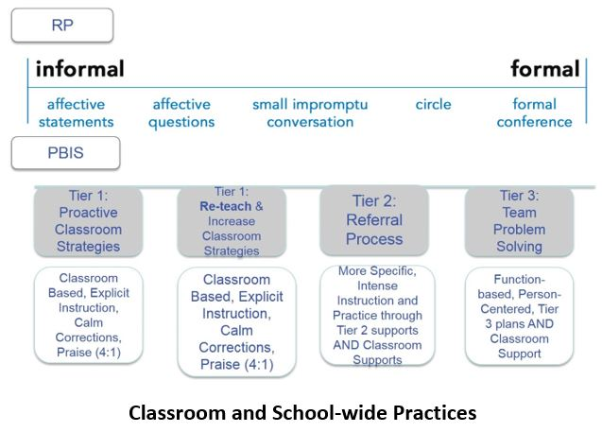
The process of integration occurred through an iterative, comprehensive review of curricular materials, fidelity measures, and guiding documents in PBIS, classroom practices, and restorative practices. Dr. Naomi Brahim, the Behavior Support Systems Coordinator; Dr. Jessica Swain-Bradway, Research Director for the Midwest PBIS Network; and Mr. Keith Hickman, Director of Continuing Education for IIRP worked collaboratively to build a common language and set of behavior strategies within the flexible PBIS framework. Importantly, this team worked to operationalize how the framework of PBIS and restorative practices could be integrated into a coherent system.
The process of alignment and integration was a crucial, and valued investment of time and resources for the district. The district leadership team felt very strongly that they could not build teacher fluency in best practices if they continued the too common practice of introducing “the next new thing,”. They wanted to fully engage teachers from the start by presenting a comprehensive list of strategies for teachers to use, and the systems necessary to support the day-to-day work in the classroom. As the district had already been experiencing implementation success of PBIS, the leadership team made great efforts to seamlessly integrate RP to strengthen the work staff had already committed to PBIS. There was a strong message from the leadership team that RP was not replacing PBIS, but instead was a complementing set of strategies to address the relational needs of the student population. The graphic below demonstrates some of the key strategies along the continuum of both PBIS and RP.
Behavior Support Systems Model –Pilot Implementation
Following the training of the District Leadership Team, and as the district was building comprehensive staff support systems, they invited schools to apply to become part of the pilot cohort for the fully integrated Behavior Support System. Eighteen schools were selected, including two alternative schools, and one state agency school. Ten schools were trained prior to the start of the 2017-18 school year, with the remainder of schools scheduled for training in summer of 2018.
A key element of the training is that it is whole-school training: custodians, clerks, nutrition workers, bus drivers, teachers, and administrators all receive the training. The leadership team understood that students interact every day with a myriad of adults, and each interaction is an opportunity to build a positive relationship, teach pro-social skills, and deepen a student’s sense of belonging. With that in mind, every district employee who interacts with students is invited to participate in the training. To incentivize participation, and show their deep commitment to the work, the district set aside a portion of their yearly budget to pay employees their daily rate for the two days of training. This message made it very clear that the district viewed this training as a priority and valued staff attendance.
The pilot school staff received training in Introduction to Restorative Practices, and Introduction to Circles. Opportunities were then provided throughout the school year for schools to send teams for additional training in Conferencing and Basic School Climate. The IIRP team, and Midwest PBIS Network continue to provide virtual technical assistance, as well as on-site to the district leadership and coaches. In spring, 2018, applications were accepted for Cohort 2, and 10 schools were selected to be in that cohort. Those schools will spend the 2018-19 schools year building their Tier 1 PBIS systems, including high-leverage classroom practices, and will be trained in RP summer of 2019.
Behavior Support Systems – Results
The initial student outcome data show promising, positive trends of decreasing office referrals for the elementary, middle and alternative schools participating in the pilot. We acknowledge that while this is promising, these data are from a small sample of 10 schools that have been implementing in the 2017-18 school year. It should be noted that the DLT interprets these successes in consideration of fidelity of PBIS and RP: the schools that showed clear, positive impact on referrals had better PBIS fidelity (as measured by the Tiered Fidelity Inventory), and better RP fidelity, as assessed by the observation tool developed by the JCPS Evaluation team.
Figure 1 shows decrease in referrals between April, 2018, and the same time the previous year for the elementary, high, and alternative schools in the RP cohort compared to the district averages. Table 1 shows the decrease in overall suspension events and repeat suspensions for the high schools in the RP cohort compared to the district averages. These early trends show very positive potential, as this is the first year of implementation for the full behavior model. While referrals decreased more notably for the elementary, high and alternative schools in the RP cohorts, the impact on suspensions for the high schools is very promising.

Figure 1. Percent average change in referrals for RP Cohorts and District Averages, 2016-17 2017-18 school years.
High School | Change in Overall suspensions | Change in Repeat Suspensions
RP Cohort Average | -29.0% | -29.9%
District Average | 1.3% | -5.1%
Table 1
Percent Change of Suspension Events, and Repeat Suspensions for High Schools only RP Cohorts and District Averages, 2016-17 2017-18 School Years

The data show a clear decrease in suspensions for the high schools in the pilot. This is substantial as a reduction in suspensions can be viewed in terms of a) interrupting the cycle of suspension to dropout, and b) the cost-savings associated with recuperated instructional time, and administrative hours. A conservative estimate is that it takes a school administrator 30 minutes to process an out-of-school suspension. This estimate translates to a saving of one professional day for each reduction of 17 suspension events. As an example, one high school, Waggener High School (a Behavior Support Systems Model School) reduced suspensions by 150 fewer suspension events this year (averaging 2.9 school days per suspension). This reduction equates to over a) 2,000 instructional hours, or 307 instructional days, gained by students at Waggener, b) recuperating nine (9) administrative work days, or approximately $3,600 in administrative time, and c) redirecting $6,092 in state funding away from exclusionary discipline and toward instructional time. These early numbers show a promising trend that should continue as schools implement the model with fidelity.
Sustainability
From the start of implementation planning, the district MTSS lead and team have planning for the internal capacity building, and long-term sustainability of the full Behavior Support Systems Model. The district had consolidated and aligned resources including FTE, professional development, coaching, evaluation planning, data collection, communication, and funding. The district team made a substantial, and long term investment in resources that have longevity beyond the grant funding, and provide hands on resources that can be used easily by the school teams, the resource teachers, and classroom teachers. The alignment, and investment will help the educators, administrators, and district leadership maintain consistent policies, best practices, and evaluation to shift the climate of the district over time to be increasingly positive.
Conclusion
Jefferson County Public Schools is completing the second year of implementation of the Behavior Support Systems Model. Year 1 saw the District Leadership Team trained, and the selection of schools for Cohort 1. Year 2 saw implementation of the model in 10 schools, with the remaining 8 schools to be trained in summer 2018, as well as the beginning of district scaling with 10 schools selected for Cohort 2. While the data represents a small sample, and it is early in implementation, the results are encouraging and demonstrate that the integration of PBIS and Restorative Practices in the Behavior Support Systems Model, and implementation of the model, can make a positive impact on student behavior.

