BLENDING CULTURES in a Colorado School
Resources:
Anti-defamation League www.adl.org
No Nonsense Nurturer http://www.ct3education.com/no-nonsense-nurturer/
Quick Start Guide to Restorative Approaches in the Classroom for Teachers by Carol Carpenter
Pheedloop link for the session

Not in Our School Anti-Bullying Program https://www.niot.org/
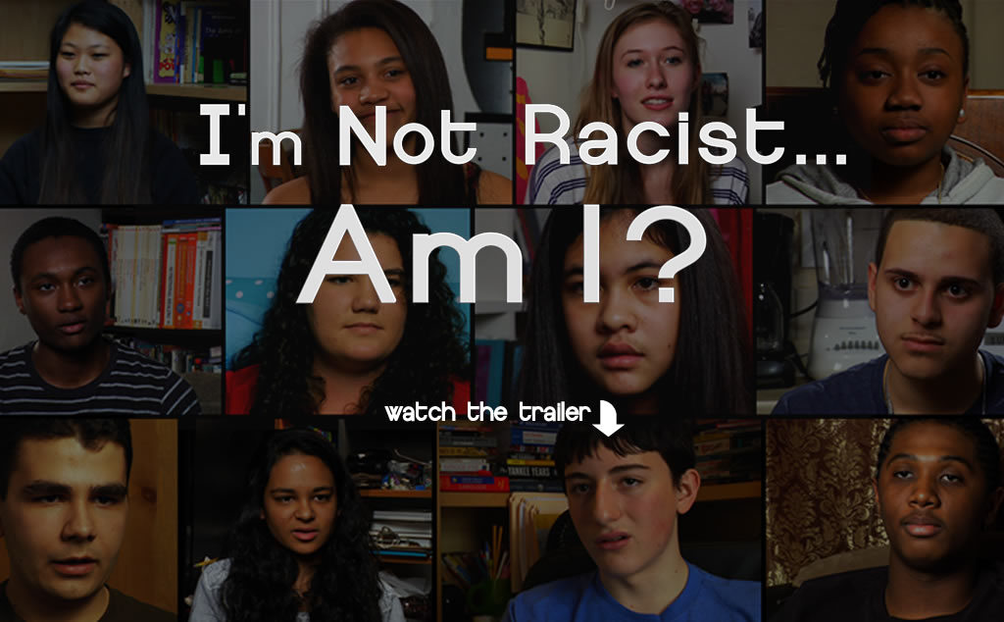 http://www.notracistmovie.com/

Mr Jack Adler, Holocaust Survivor,
Speaker and Author at www.amazon.com
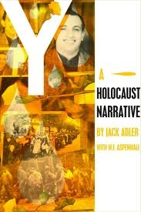

Jovan Mays
September 2016 TED Talk
“You are the exclusive author of your story” YouTube
https://www.youtube.com/watch?v=9-QYDFiWn-s
